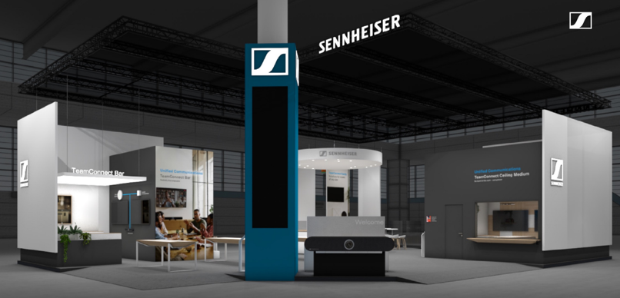

Sennheiser Group Significantly Expands ISE 2024 Presence
With booths in the Collaboration Area (Hall 3) and the Audio Space (Hall 7), the Group will showcase even more exciting solutions to attendees

Wedemark, January 24, 2024 – The Sennheiser Group is pleased to announce an expanded presence at Integrated Systems Europe (ISE) 2024 in Barcelona, Spain on January 30 – February 2. For the first time at ISE, the group will have two booths to feature its solutions for Business Communication (3C500) and Professional Audio (7A700) at the FIRA Barcelona, Gran Via. Attendees will have the opportunity to experience the full potential of the group brands via interactive demo spaces and product displays highlighting their latest audio solutions.

Become Immersed in the Sennheiser Business Communication Experience
At the Business Communication booth in the Collaboration Area, visitors can explore the Sennheiser TeamConnect Family, an extensive range of unified communication solutions tailored for meeting rooms and lecture spaces of all sizes. There, attendees will find the complete Sennheiser Business Communication portfolio, including the TeamConnect Ceiling Solutions (TeamConnect Ceiling Medium and TeamConnect Ceiling 2), the new TeamConnect Bar Solutions (TeamConnect Bar S and TeamConnect Bar M), the EW-DX digital wireless microphone series and MobileConnect, an innovative, scalable, app-based accessibility solution.

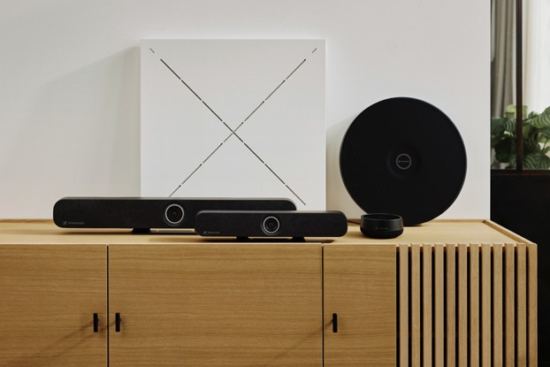 | Sennheiser TeamConnect Family

Introducing Headmic 4
Sennheiser's new high-quality, ultra-lightweight (7 g) condenser cardioid neckband microphone for vocal and speech applications will be introduced for the first time publicly at ISE 2024. Headmic 4, the best cardioid head mic from Sennheiser, is a high-quality, permanently polarized condenser head mic with cardioid pick-up pattern, designed for professional applications. The adjustable neckband is visually unobtrusive and comfortable to wear. This ultra-lightweight, yet robust head mic features a KE 4 cardioid mic capsule, comes with two connector options (3.5 mm jack and 3-pin) and is available in three colour variants (beige, black and silver). It is also compatible with all Sennheiser bodypack transmitters.

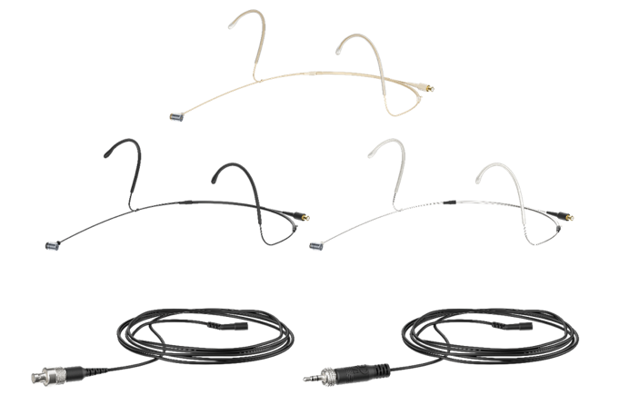 | Be sure to check out the new Headmic 4 when visiting the Sennheiser Business Communication booth at ISE

Simplify Your Space Planning: Sennheiser Room Planner
Experience Sennheiser’s upgraded Room Planner at ISE 2024. The Sennheiser Room Planner, now more intuitive and user-friendly, streamlines your device planning and room design, unlocking the full potential of your Sennheiser solutions. Join us at ISE 2024 to explore the latest version of the Sennheiser Room Planner, now enhanced with significant new features.

Sennheiser has introduced the Room Plan Upload Feature, allowing for personalized audio and video designs when uploading room plans. Additionally, the installation height adjustments for ceiling microphones have been refined, offering more precise planning for your specific meeting environments. Product guides and specifications have now been integrated directly within the planner, providing immediate access to all the essential information you need for efficient planning.

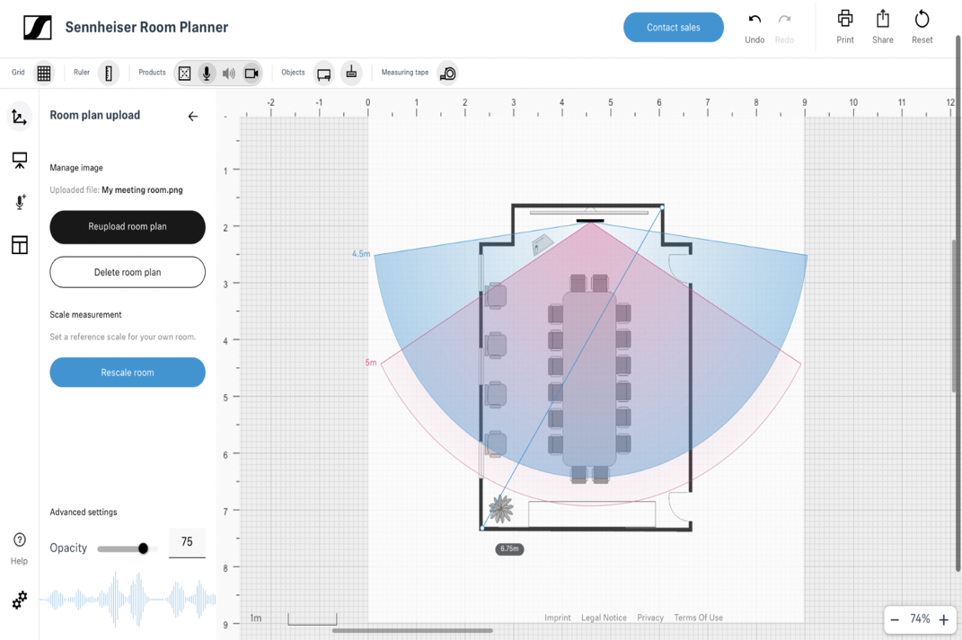
Visit the Sennheiser Business Communication booth to see the updated Room planner in action,
or if you are unable to attend ISE 2024, explore its new features online at roomplanner.sennheiser.com.

Sennheiser’s Global Partnerships and Alliances at ISE 2024
The Sennheiser Business Communication booth will feature an interactive touchscreen for attendees interested in discovering the Sennheiser collaborations that streamline integration and deliver engaging experiences.

At ISE 2024, integrators, consultants, and end-users can experience the full potential of Sennheiser products when paired with solutions from its global partners and alliances. During the show, Sennheiser will collaborate with 20 partners on a campaign to highlight the benefits of its network of partners and alliances.

ISE attendees are encouraged to participate in an app-led scavenger hunt across Sennheiser and partner booths. Participants will be rewarded with exclusive Sennheiser-branded socks and the chance to win a TeamConnect Bar Medium.

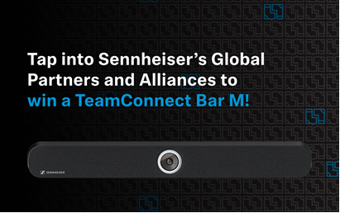

Visit mautic.sennheiser.com/iseperfectpair for more
information and instructions on how to participate in the scavenger hunt.

Sennheiser Mobility: New Dimensions in Automotive Entertainment
At Sennheiser’s second booth in Hall 7, A 700, ISE visitors can take a seat in the new CUPRA Tavascan and enjoy new dimensions in automotive entertainment with AMBEO Concerto, the latest immersive audio software innovation from Sennheiser Mobility.

The CUPRA Tavascan opens up new dimensions in car entertainment with Sennheiser Mobility’s AMBEO Concerto software | 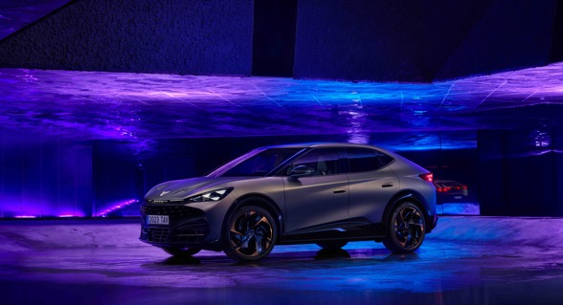

The proprietary AMBEO Concerto software has been meticulously fine-tuned to match CUPRA’s first all-electric SUV coupé. The software analyses any piece of music for its fundamental vocal and instrument components as well as all room information, and distributes the audio in a yet unheard quality through the Tavascan’s 12-loudspeaker audio system. More information on the cooperation between the two brands can be found here.

Welcome to the Immersive Zone
An Immersive Zone fitted with Neumann and Merging Technologies solutions in Hall 7, A 700 gives audio professionals a glimpse of state-of-the-art audio mixing. The 5.1.4 system consists of Neumann’s latest KH 150 monitor speakers and KH 750 subwoofer, while playout is generated by Merging Technologies’ Ovation.

Originally developed for theme park use, Ovation has evolved to be the leading solution for many applications in AV such as museums, grand openings, and shows where it is used as a playout system and a show controller. It has also been used extensively as a solution for live-to-air broadcasts. One can directly playback multitrack and immersive content and has the ability to edit at any time with just one click. Live demos at the stand will demonstrate Ovation’s ability to import Dolby Atmos ADM files and its Open Show Control (OSC) capabilities for live events in an immersive environment.

New “Venue Mission” Software from Merging Technologies
For the live sound market, Merging Technologies showcases the new Venue Mission for Anubis. Venue Mission finds application in a wide array of use cases, ranging from orchestral performances and studio recordings, complex band monitor setups as well as smaller bands without monitor engineers, to speaking booths/ADR studios. Venue Mission has been successfully used for the Louis Vuitton Show at Paris Fashion Week, the recent French tour of the Queen Symphonic, and Johnny Symphonique. Performers benefit from access to their own personal monitoring mix, while the microphone and instrument inputs can be shared on the network for remote control and monitoring by the PA mixer or recording engineer.

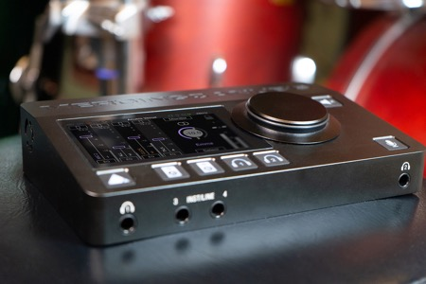 | Merging Technologies will showcase its Venue Mission software and its personal mix for musicians

Neumann Studio Highlights
Also on show will be a selection of Neumann studio microphones and the Neumann MT 48 audio interface. This has received an eagerly anticipated feature update, which allows working in immersive audio formats.

With the new feature update, the Neumann MT 48 audio interface will allow working in immersive audio formats | 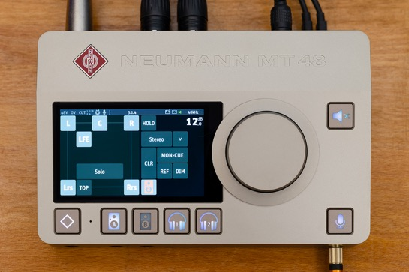

Neumann Live Sound Products
The Miniature Clip Microphone System (MCM) has quickly become a new benchmark in instrument miking. The system will be expanded by the KK 13 omni capsule as an alternative to the standard cardioid KK 14 capsule, as well as additional gooseneck and cable options.

The Neumann line of vocalist capsule heads for wireless systems will also be expanded to make the sound of the cardioid KK 104 and super-cardioid KK 105 true condenser capsule heads available for third-party wireless microphones, too.

Neumann’s MCM System is expanded by a new omni capsule as well as goosenecks and cables in various lengths for optimum adaptation to customer requirements | 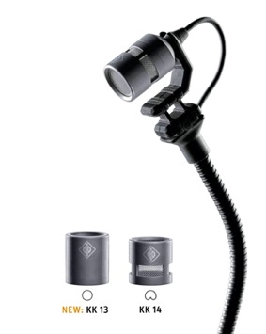

Wireless Solutions Now and in the Future
The next generation of wireless audio can be discovered with the ground-breaking Sennheiser WMAS (wireless multichannel audio systems) broadband technology. The Tuesday and Wednesday of the show will see five expert sessions taking place to inform customers about the possibilities of this new technology.

With a focus on professional live productions, the EW-DX digital UHF wireless microphone system will be on show at Sennheiser’s new second booth, too. New components, such as the EM 2 Dante, a half-rack (9.5”) two-channel receiver, a rackmount charging solution and control software have been added to the system, with the four-channel Dante receiver to round off EW-DX in mid-2024.

Selected EW-DX components for live audio | 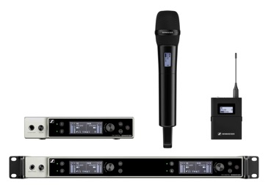

Flexible and Cost-effective Interpretation Solution
Interpretation at conferences, business meetings and broadcast events is more in demand than ever but often associated with complex set-ups and cost. Merging Technologies has joined forces with Sennheiser’s business communication experts to create a very flexible and cost-effective interpretation solution. At its heart is the Anubis Commentary Unit Mission, with a Hapi Mk II serving as the connection point to the console, PA or conferencing system. Connect Sennheiser headsets (mic/headphone combos) to the Anubis and the interpretation desk is ready. This interpretation solution can be remotely controlled via a VPN and the IP address of each Anubis.

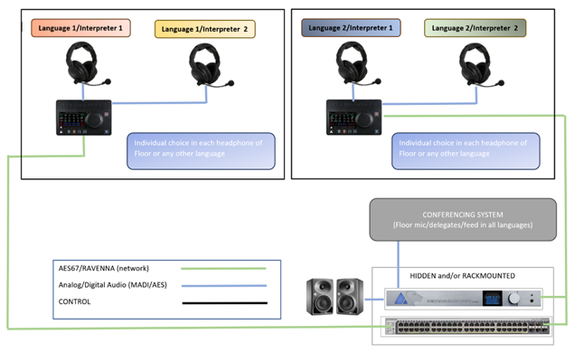
Visit the Sennheiser Group at ISE, Fira Barcelona, stands 3C500 and 7A700.

(Ends)

The images accompanying this media release can be downloaded here.

About the Sennheiser Group

Building the future of audio and creating unique sound experiences for our customers - this is the aspiration that unites the employees of the Sennheiser Group worldwide. The independent family-owned company Sennheiser was founded in 1945. Today, it is managed in the third generation by Dr. Andreas Sennheiser and Daniel Sennheiser and is one of the leading manufacturers in the field of professional audio technology.
sennheiser.com | neumann.com | dear-reality.com | merging.com

